[SQL - JournalDev](https://www.journaldev.com/16767/sql) Good Site for SQL

1. Create A Table

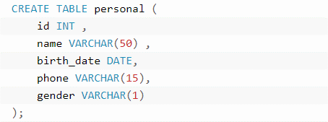

1. Insert data into table

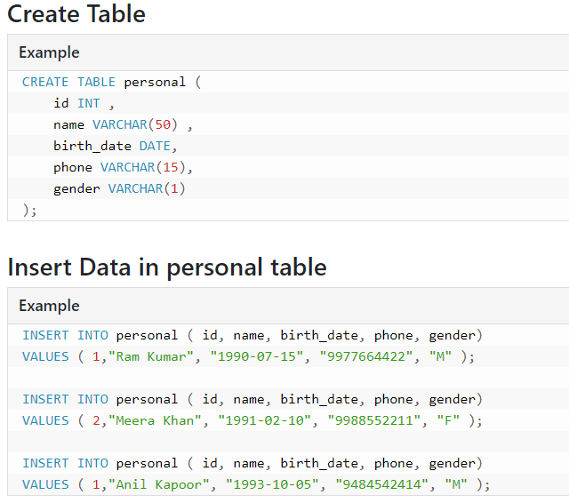

1. Make Some constraints on our table

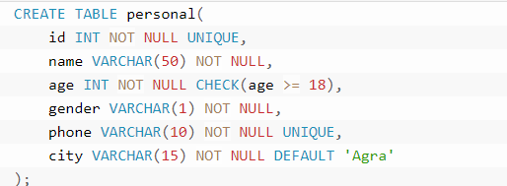

Isme Id null ni hgi and and whi data save hga jisme age >=18 h

1. Select and where clause

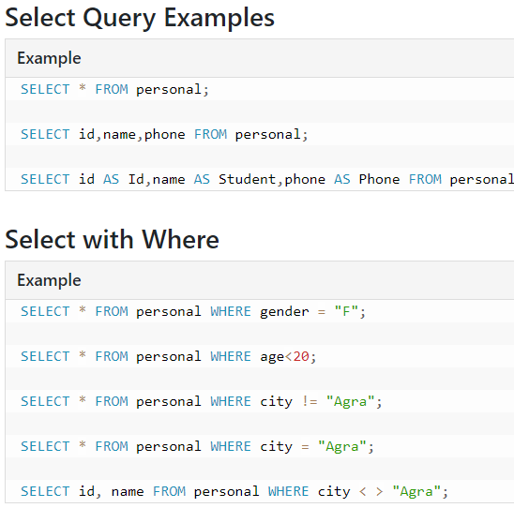

1. AND OR NOT

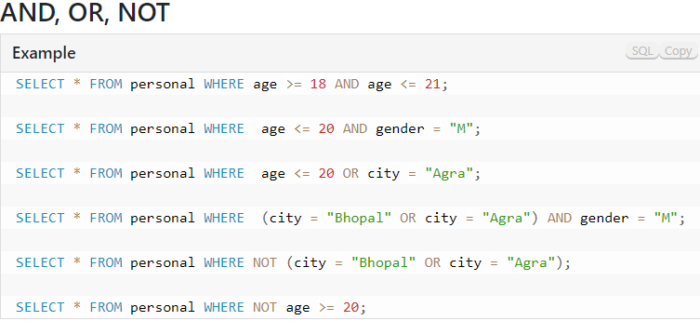

1. SQL | BETWEEN

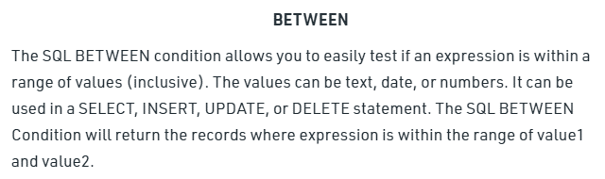

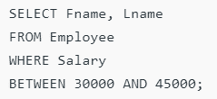

1. SQL | IN

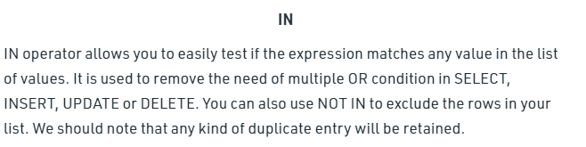

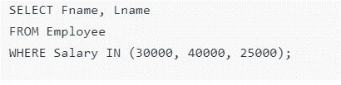

1. SQL | Like Operator

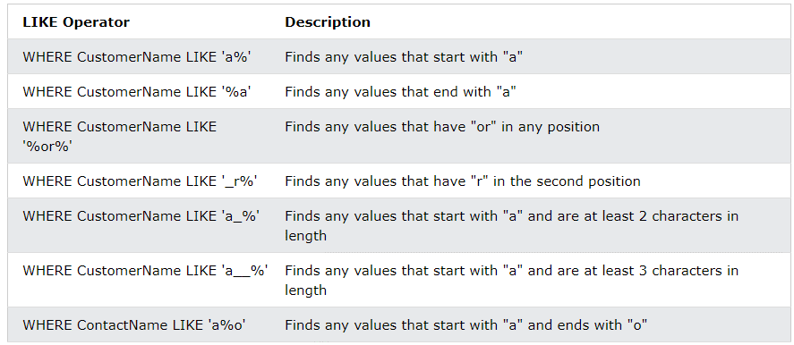

1. SQL | Order By

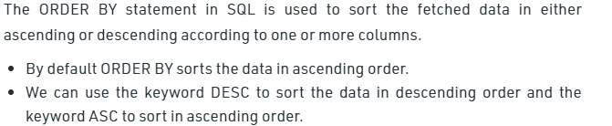

Sort By on the basis of more than one column



1. SQL | Distinct

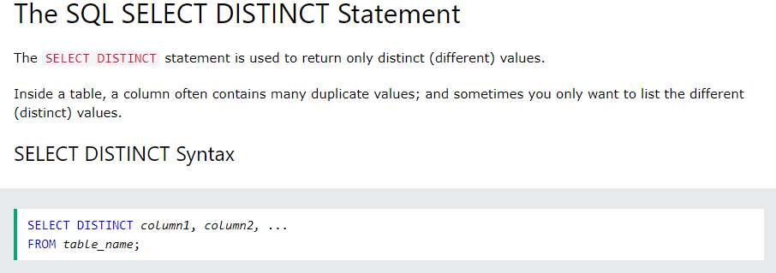

1. SQL | Limit

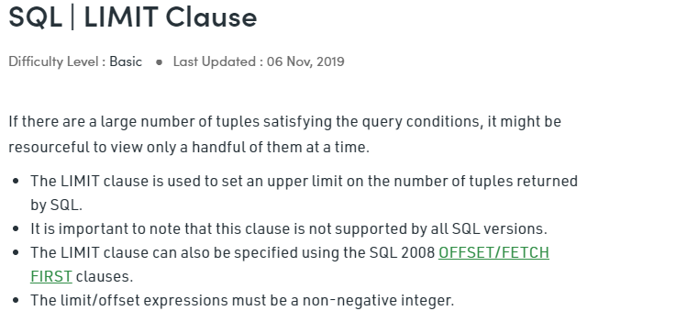

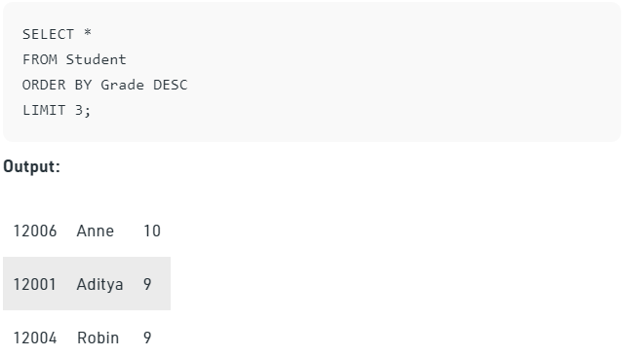

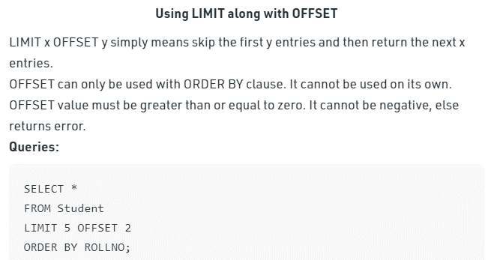

1. SQL Aggregate Function

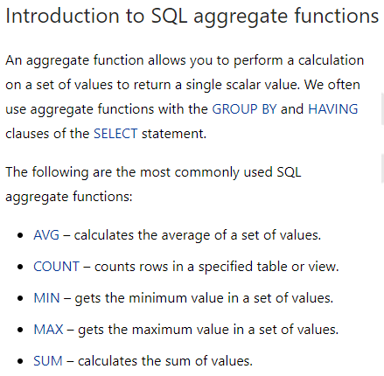

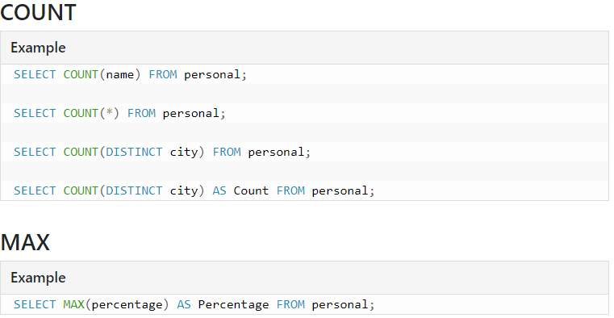

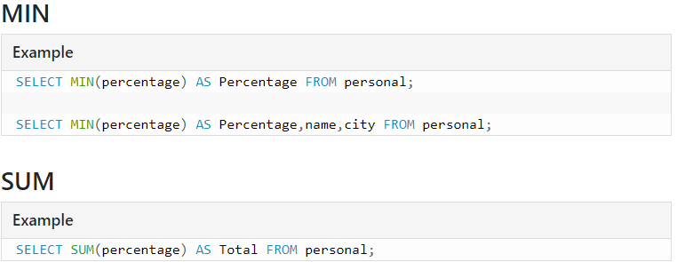

1. SQL | Update

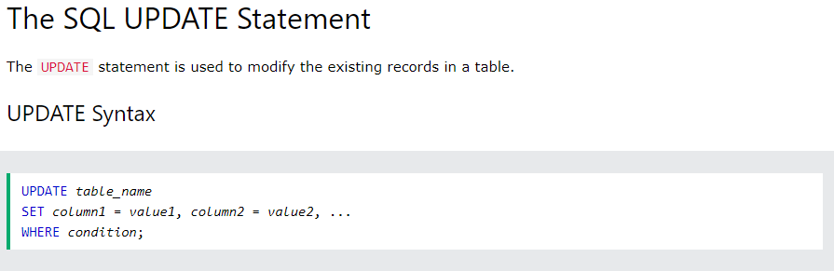

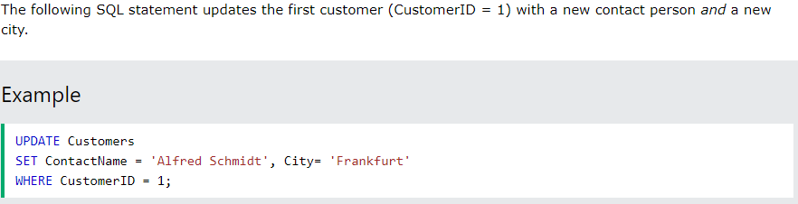

1. SQL | Alter

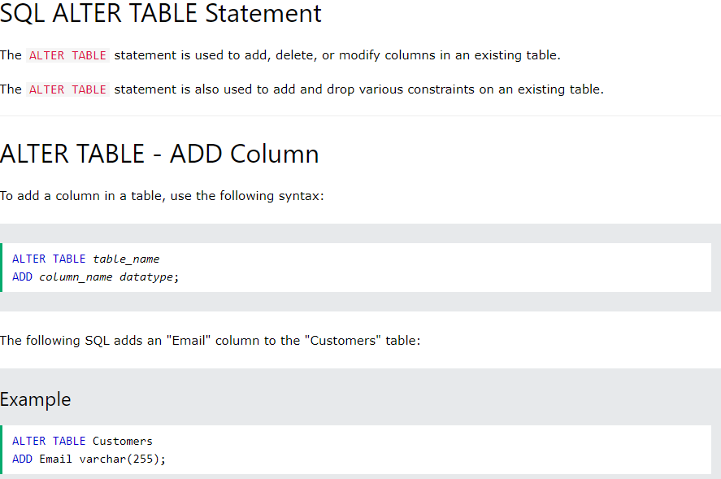

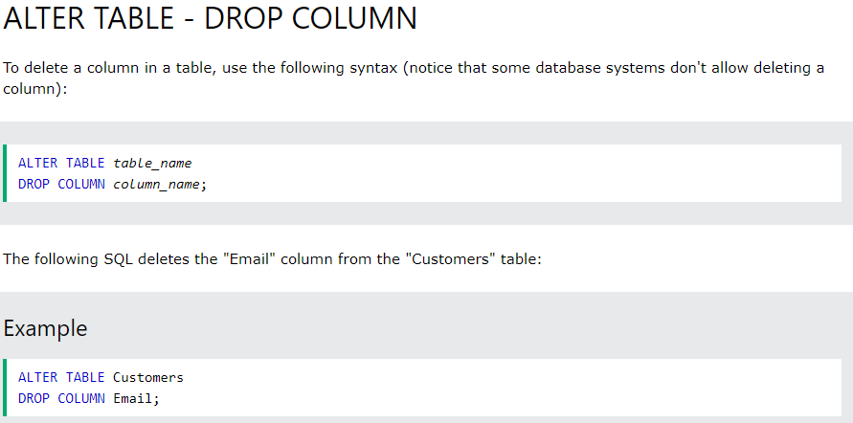

1. SQL Commit & Rollback

[SQL Commit And Rollback - JournalDev](https://www.journaldev.com/23932/sql-commit-sql-rollback) yha se pdh lena acha btaya h with example

1. SQl | Delete

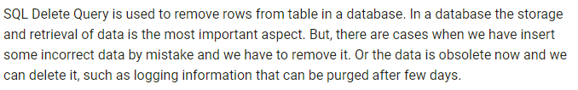

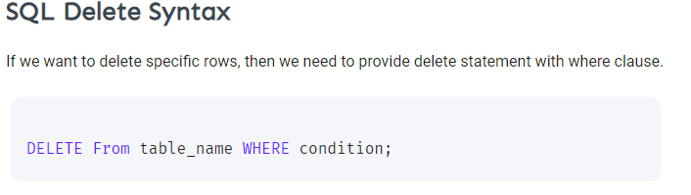’ 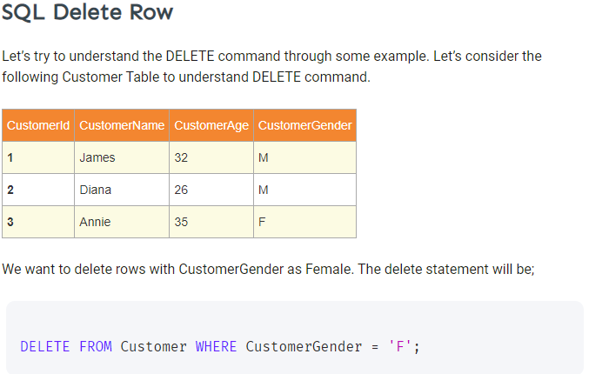

1. Primary Key 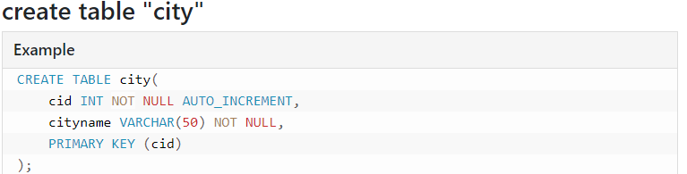
2. Foreign Key

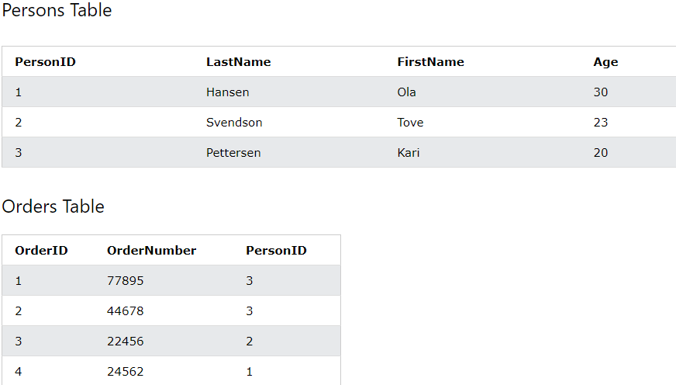

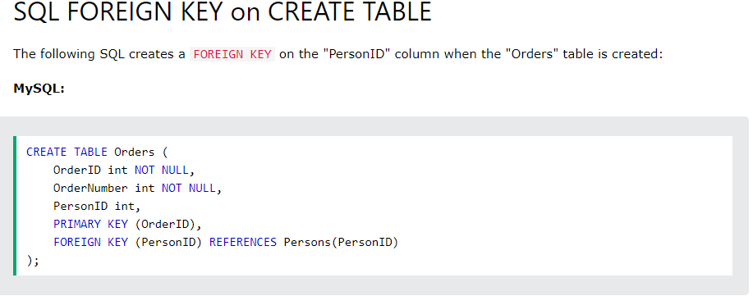

1. Inner Join

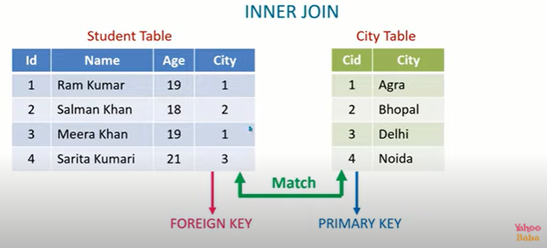

Syntax

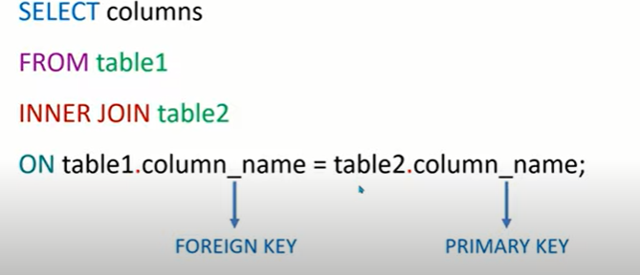

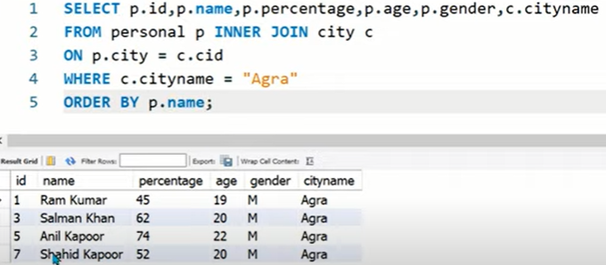

1. SQL || Group by

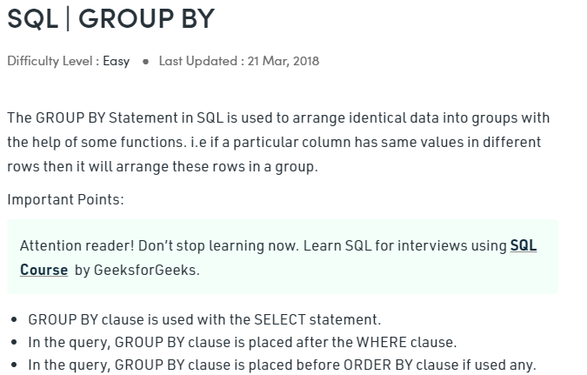

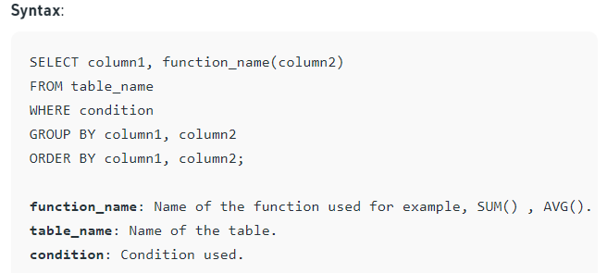

1. **SQL || Having**

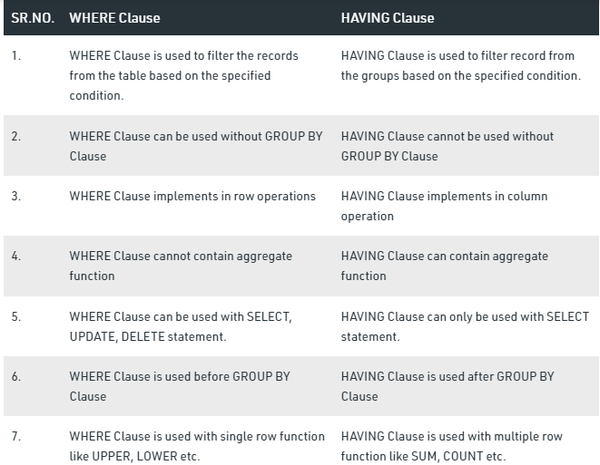

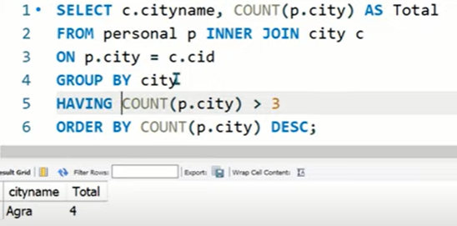

1. **SQL Subquery**

Esme Ek query k andr dsri subquery likhi hoti h.

In MySQL, a Subquery is defined as a SELECT SQL Statement that is used inside another SQL statement to calculate the results of outer queries. Simply in SQL, a Subquery is an inner query which is placed within an outer SQL query using different SQL clauses like WHERE, FROM, HAVING and with statement keywords such as SELECT, INSERT, FROM, UPDATE, DELETE, SET or DO, accompanied with expressional operators or logical operators.

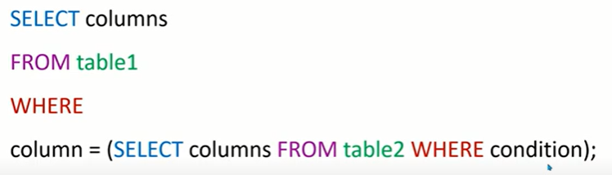

Iska Example Yahoo Baba pr dekh lena.

1. **IF and CASE**

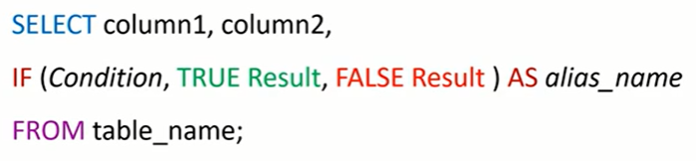

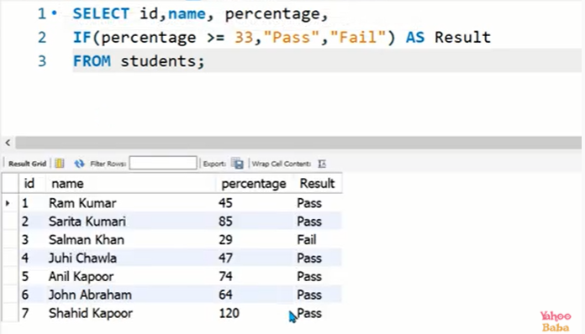

CASE

Case statement ka use wha hota h jha multiple condition hme lgani hoti h

